**1. Introduction**

In the present world of digital communication, the use of voice-based technology is increasing rapidly. Voice is not only used for conversations but also plays a key role in security, healthcare, research, and entertainment. Many existing systems either focus on converting voice into text (speech recognition) or on verifying identity through biometric voiceprints. However, there are very few projects that allow a simple and combined way of managing, storing, searching, and comparing voices in a single platform.

This project addresses that gap by designing and developing a Unified Voice Application. The system is innovative because it integrates multiple tasks—voice library creation, sample matching, and direct comparison—into one lightweight, easy-to-use tool. The originality lies not in creating a completely new algorithm, but in using available techniques in a new combination that makes the system more practical, affordable, and accessible.

**2. Novel Approach**

The project’s novelty comes from the way different functions are brought together in a single framework.

* **Voice Library Management**: A database is integrated with the system to store uploaded audio files permanently. Each file is indexed and labeled, making it easy to build a personal or organizational voice collection.
* **Voice Matching**: Instead of searching manually, the system provides automated matching by comparing the new input voice with the stored library. This feature is highly useful for quick identification.
* **Direct Comparison**: Two voices can be uploaded and compared side by side. The system calculates a similarity score using **cosine similarity** and **Dynamic Time Warping (DTW)**, and then gives a verdict such as *Same*, *Likely Same*, or *Different*.

**Innovative points in methodology:**

1. **Combination of cosine similarity + DTW**:
   * Cosine similarity works well with feature vectors (MFCC values).
   * DTW handles cases where the speech speed or style is different but the speaker is the same.  
     By combining both, the project achieves better reliability.
2. **User Interface Design**: Many research codes for voice comparison exist, but they are difficult for non-technical users. This project uses **Streamlit** to make a clean, web-based interface so anyone can use it without coding knowledge.
3. **Local Database (SQLite)**: Instead of depending fully on cloud services, the system uses a simple and portable database. This reduces costs and allows offline use if needed.

**3. Comparison with Existing Solutions**

To prove originality, it is important to compare with existing solutions.

* **Market/Industry Tools**
* **Google Speech API / Microsoft Azure Speech** – These tools are advanced but mainly designed for converting voice into text. They are paid services and do not provide direct voice-to-voice comparison.
* **Commercial Biometric Voice Systems** – These are accurate but very costly, and not suitable for student projects or small organizations.
* **Research Scripts (Python, MATLAB)** – Many academic codes exist for MFCC or DTW, but they are standalone, lack proper user interface, and do not include library storage.
* **Proposed System Difference**

The uniqueness of this project lies in:

* Providing **both library search and direct comparison** in one tool.
* Offering a **free and open-source solution**.
* Being **lightweight and easy to deploy** (runs on localhost or cloud platforms like Streamlit Cloud).
* Suitable for **research, academics, and practical use cases** without heavy hardware or licensing costs.
* **Comparison of Existing Solutions with Proposed System**

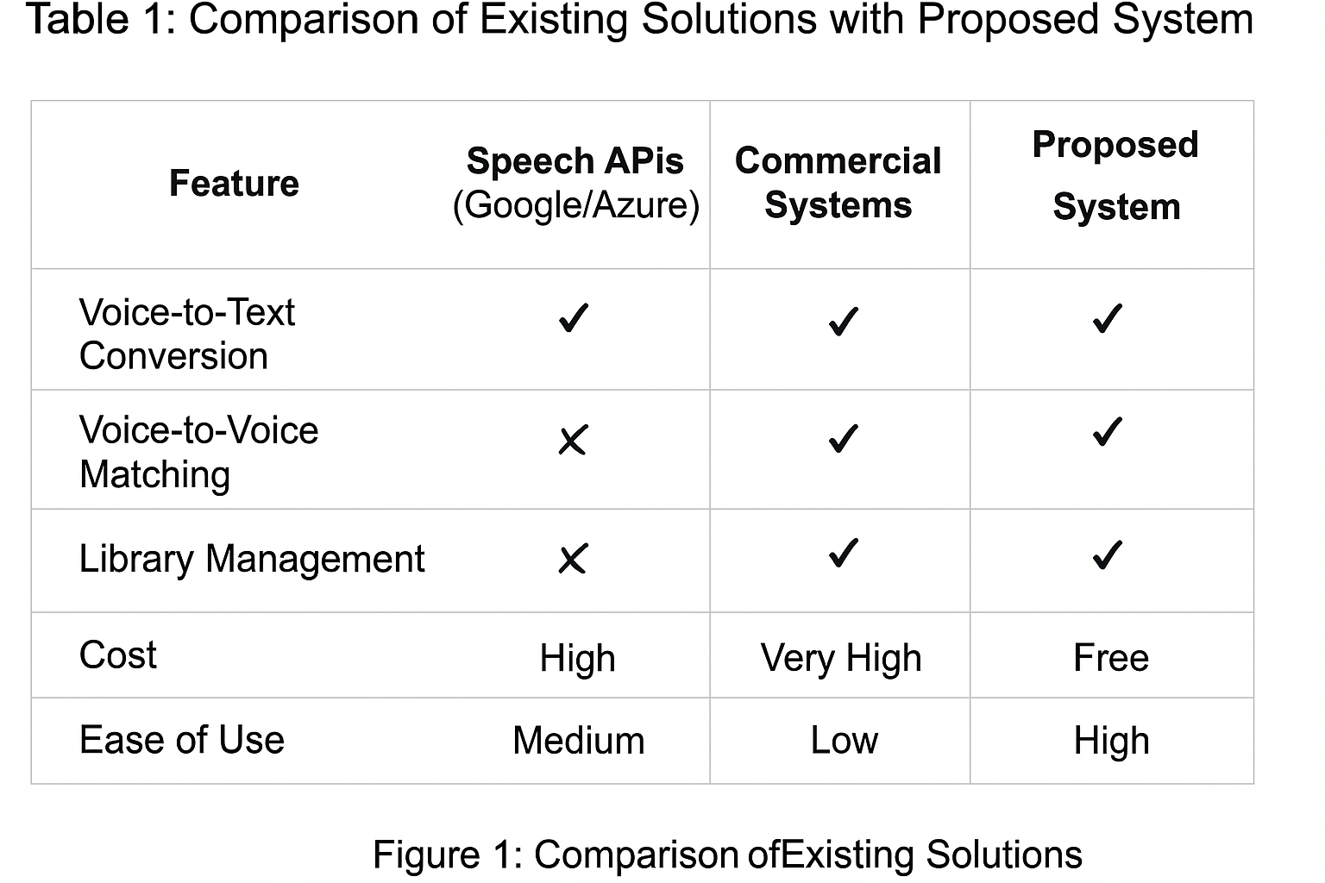

**4. Contribution to ICT Field**

This project contributes to the ICT domain in multiple ways:

1. **Educational Value**:  
   The system can be used in classrooms to demonstrate concepts of **digital signal processing, feature extraction, and similarity measurement**. It makes theoretical concepts practical and easy to understand for students.
2. **Cybersecurity Applications**:  
   The project can be extended for **voice authentication** in login systems. Instead of passwords, users can speak a phrase to verify their identity.
3. **IoT and Smart Devices**:  
   Smart devices such as speakers or home assistants can integrate voice matching to recognize different family members and personalize services.
4. **Healthcare and Forensics**:
   * In healthcare, voice changes can indicate diseases like Parkinson’s. Storing and comparing voice samples over time can help in diagnosis.
   * In forensic science, the tool can assist in matching suspects’ voices from recordings.
5. **Interdisciplinary Innovation**:  
   The originality of the project lies in combining three ICT areas—**signal processing (MFCC, DTW), database management (SQLite), and web technologies (Streamlit, Python)**—into a single, usable product.

**5. Conclusion**

The project demonstrates innovation by combining existing technologies in a **new and original way**. While many solutions exist individually for speech recognition, biometric identification, or feature extraction, this project’s uniqueness lies in integrating them into one accessible platform.

It is cost-effective, easy to use, and adaptable to various domains, which makes it a valuable contribution for ICT students, researchers, and small organizations.